Group Project 1: Predictive Statistical Problems Assignment Part 2

Andre Ricardo Caralli Junior,
Bruno de Arantes Leite Sassi,
Luciana Alves de Queiroz Popa, and
Tiago Caramello Ceolato.

Master of Data Analytics, University of Niagara Falls Canada
Predictive Analytics (DAMO-510-1)
Dr. Zeeshan Ahmad
June 13th, 2025

1. Statement of Purpose
Lifestyle choices are a significant determinant of long-term health, contributing to approximately 60% of an individual's overall health and quality of life (Farhud, 2015). Unhealthy habits, such as smoking, excessive alcohol consumption, a poor diet, and a sedentary lifestyle, are primary contributors to chronic conditions like cardiovascular disease, obesity, and metabolic issues.
The goal of this project is to create a predictive model that estimates the likelihood of individuals experiencing health issues. This model will use data from addictive behaviors, such as smoking and drinking, as well as lifestyle factors, including exercise, diet, sleep, and mental health.
The goal of this project is to create a predictive model that estimates the likelihood of individuals experiencing health issues. This model will use data from addictive behaviors, such as smoking and drinking, as well as lifestyle factors, including exercise, diet, sleep, and mental health. Machine learning techniques can identify the relationship between these habits and health outcomes, providing valuable insights for public health interventions aimed at reducing addiction and improving health.
Leveraging a dataset of 3,000 individuals with addiction patterns will allow us to uncover predictive factors for health issues and explore strategies to support public health policies and prevention initiatives.
2. Scope of the Project
The goal of this project is to build a predictive model that estimates the likelihood of an individual experiencing health issues based on their addictive behaviors and other demographic data. The dataset includes 3,000 individuals exhibiting smoking and drinking addiction patterns, as well as key lifestyle features such as age, exercise frequency, diet quality, hours of sleep, BMI, and mental health status.
The project involves data preparation (cleaning and transformation), exploratory data analysis (EDA), and applying machine learning models, such as logistic regression and classification trees, to predict the binary variable ‘has_health_issues’. The goal is not to provide medical diagnoses, but rather to predict health risks based on behaviors and provide insights for policymaking and prevention strategies.
3. Background Research and Literature
When it comes to smoking and drinking, several studies are available to inform the links between them and long-term health issues. According to the World Health Organization (WHO, 2023), tobacco is responsible for more than 8 million deaths a year, including the non-smokers – people who inhale smoke because they are exposed to it. Another key insight provided by WHO (2023) is that in 2020 36.7% of tobacco users were man, while a minority of 7.8% were women. Other data that highlights the public importance of studies regarding smoking is that it is highly responsible for diseases such as lung cancer, chronic respiratory disease, and tuberculosis, but beyond that another alarming statistic informed by WHO (2019) was that more than 60,000 children under 5 years old die due to second-hand smoke.
Alcohol addiction is also very harmful with 2.6 million deaths in 2019 related to alcohol consumption, with 2 million being among men (WHO, 2024). Apart from that, the direct diseases caused by alcohol addiction are liver diseases, heart diseases, mental health and behavioral conditions, as well as many cancer types, such as breast, liver, head, and neck cancer. Additionally, according to WHO (2024), young people are more affected by alcohol addiction in general with people between 20 and 39 years being 13% of the alcohol-attributable deaths.
Furthermore, the co-occurring usage of both smoking and alcohol raises concerns, since around 20% of smokers also drink heavily, which is linked with worse morbidity and mortality, but has no current treatment or best practices to treat both addictions together (King & Fucito, 2021). Given all the issues and concerns brought by cigarettes and alcohol addiction, it is clear that society and public health are negatively affected by those habits, and studies related to this field are more than welcome to understand how governments can make policies better address these issues. Predictive modeling, particularly machine learning approaches, can offer early insights into at-risk populations and inform effective public health strategies to reduce addiction and its societal impact.
4. Dataset Overview and Data Cleaning
4.1 Data Overview
The dataset used in this project was obtained from Kaggle and provided by Yadav (n.d.). It consists of data collected from 3,000 individuals who exhibit addiction behaviors related to smoking and drinking, as well as various demographic and lifestyle factors. These factors include age, employment status, income, mental health, exercise habits, diet quality, sleep duration, and social support. This dataset is ideal for building a predictive model aimed at understanding the relationship between lifestyle choices and health outcomes.
Key Variables:
The dataset contains several key variables, categorized into predicted and explanatory variables:
- Predicted Variable:
  - has_health_issues - A binary variable indicating whether the individual reports having health issues (Yes/No).
- Explanatory Variables:
  - Addiction-related: smokes_per_day, drinks_per_week, age_started_smoking, age_started_drinking, attempts_to_quit_smoking, attempts_to_quit_drinking
  - Lifestyle and Health: exercise_frequency, diet_quality, sleep_hours, bmi, mental_health_status, social_support, therapy_history
  - Demographic-related: age, gender, education_level, employment_status, annual_income_usd, marital_status, children_count, country
4.2 Data Cleaning and Preprocessing
The cleaning and preprocessing phase was essential to prepare the data for analysis. This phase involved several key steps to ensure the dataset was reliable and ready for model development.
- Removing Irrelevant Columns:
Several columns in the dataset, such as id, name, and city, were removed as they did not contribute useful information for the analysis. These columns are typically used for identification purposes but do not aid in predicting health issues.
- Handling Missing Data:
The dataset contained missing values represented as 'None' entries in several columns. These 'None' entries were replaced with ‘Never’ to facilitate processing. The missing values were then analyzed and will be addressed in the Feature Engineering phase. The columns with missing values included:
- education_level: 420 missing entries
- social_support: 753 missing entries
- therapy_history: 1014 missing entries
These missing values will be imputed or handled appropriately based on the importance of each feature in the predictive modeling process.
- Data Type Validation:
It was crucial to ensure that each feature in the dataset was assigned the correct data type for further analysis. The dataset contained a mix of:
- Numerical: Integer (int64), Float (float64)
- Categorical: String (object), representing factors like gender, education_level, and mental_health_status
- Boolean: For the target variable has_health_issues, which indicates the presence of health issues (Yes/No).
These data types were validated, ensuring that categorical variables were appropriately encoded for machine learning models.
Conclusion
The dataset is now ready for the next phase of analysis, where exploratory data analysis (EDA) will be performed to better understand the relationships between lifestyle factors and health outcomes. The preprocessing steps outlined ensure that the data is clean, well-structured, and appropriate for predictive modeling using techniques such as Logistic Regression and Classification Trees.
5. Exploratory Data Analysis (EDA) Section
The dataset offers insights into various demographic, lifestyle, and health-related variables, including addiction behaviors, mental health status, exercise habits, diet quality, and more. The main goal of this Exploratory Data Analysis (EDA) is to explore how health issues (i.e., whether an individual reports having health issues or not) correlate with different behavioral and demographic factors. The section below presents key patterns and trends observed in the dataset, supported by visualizations.
  - Key Insights from the EDA
- Health Issues Distribution
The bar chart in Figure 1 shows the distribution of individuals with and without health issues. The "False" bar (individuals without health issues) is slightly larger than the "True" bar (those with health issues), but the distribution is nearly 50/50. This serves as a crucial baseline for understanding the health status distribution across the dataset.
Figure 1. Distribution of health issues.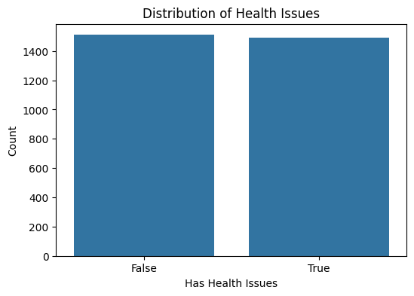
Note. This bar chart presents the distribution of individuals with and without health issues.
- Exercise Frequency and Health Issues
The first graph (Figure 1) presents the relationship between exercise frequency and health issues. It shows that individuals without health issues tend to exercise more frequently, with higher counts in the "Daily" and "Weekly" exercise categories compared to those with health issues.
Figure 2. Exercise frequency by health issues.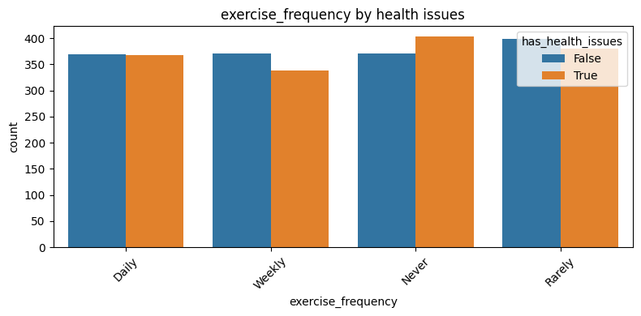
Note. This graph illustrates the exercise frequency distribution for individuals with and without health issues.
- Social Support and Health Issues
The second graph (Figure 2) displays the distribution of social support among individuals with and without health issues. It shows that individuals with health issues report slightly weaker social support, though most individuals report moderate to strong support.
Figure 3. Social support by health issues. 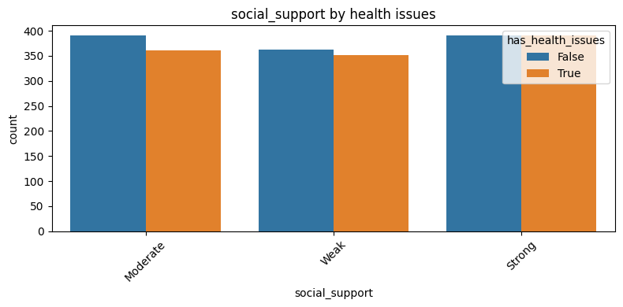
Note. This bar chart depicts the level of social support among individuals with and without health issues.
- Diet Quality and Health Issues
The third graph (Figure 3) shows the relationship between diet quality and health issues. Both groups show balanced distributions across diet quality ratings, with a slightly higher number of individuals with health issues reporting "Poor" diet quality.
Figure 4. Diet quality by health issues. 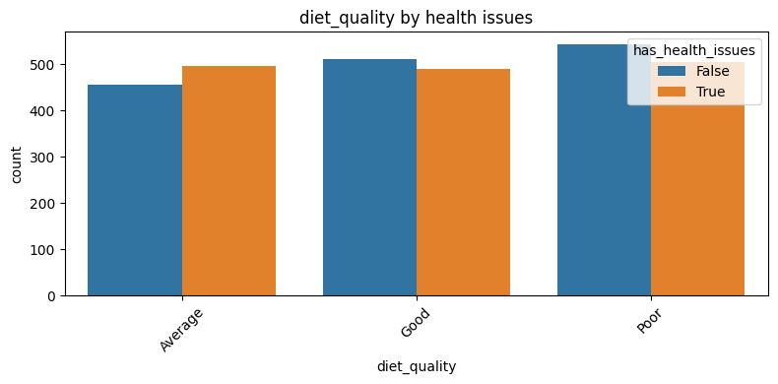
Note. The bar chart in this figure compares diet quality between individuals with and without health issues.
- Mental Health Status by Health Issues
The fourth graph (Figure 4) shows that individuals with health issues report poorer mental health compared to those without health issues, with a higher count of "Poor" mental health status among the former group.
Figure 5. Mental health status by health issues. 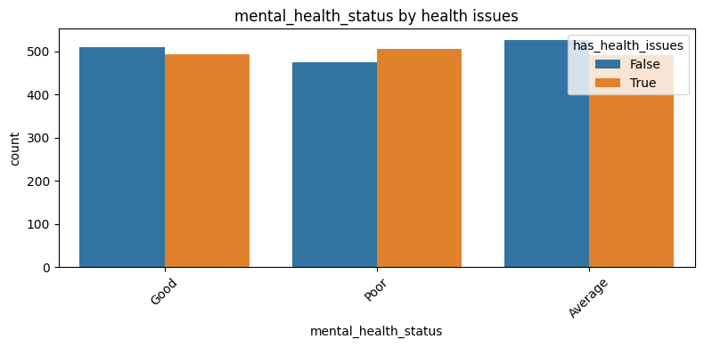
Note. This graph compares mental health status between individuals with and without health issues.
- Age Distribution by Health Issues
The distribution of age by health issues, shown in Figure 5, reveals trends across age groups. Individuals with health issues tend to show a slightly different age distribution compared to those without health issues.
Figure 6, Age Distribution by Health Issues 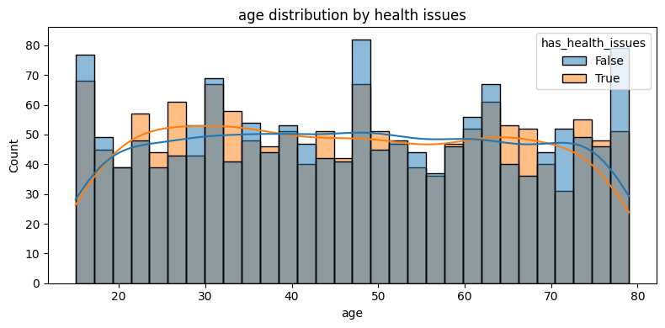
Note. This distribution chart shows the age breakdown of individuals with and without health issues.
- Demographic Factors
Variables such as gender, employment status, marital status, and education level reveal key trends based on health issues. For example, individuals without health issues tend to have better employment status and more stable marital relationships. To deepen this analysis, we can consider the distribution of marital status based on health issues (Figure 7).

Figure 7: Marital Status by Health Issues 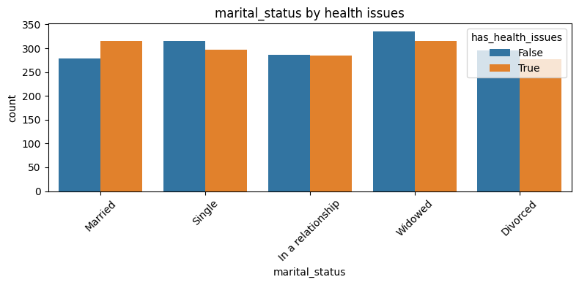
Note. The graph indicates that individuals with health issues are slightly less likely to be married or in a stable relationship compared to those without health issues. This observation could suggest that health problems may affect personal relationships, potentially due to the strain health issues place on partnerships.
Additionally, income levels could be explored as another demographic factor. The distribution of income by health issues (Figure 8) suggests that individuals without health issues tend to occupy higher income brackets, highlighting the potential connection between better health and improved financial outcomes. This reinforces the notion that health may influence employment opportunities and economic stability.
Figure 8. Income distribution by health issues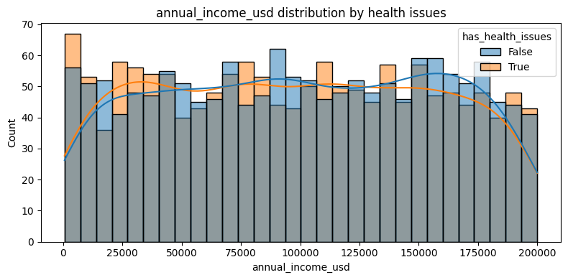
Note. The graph reveals that individuals without health issues have a higher presence in higher income ranges, which could reflect the increased access to resources and better job stability.
- Smoking and Drinking Behavior
The distribution of smoking behavior shows a higher prevalence of smoking among individuals with health issues. This aligns with existing literature suggesting that health problems are often correlated with higher rates of smoking, potentially as individuals cope with stress or other underlying factors. The smoking behavior distribution (Figure 9) clearly demonstrates that those with health issues tend to smoke more frequently, with higher counts observed in the 7-10 cigarettes per day range.
Figure 9: Smoking Behavior by Health Issues 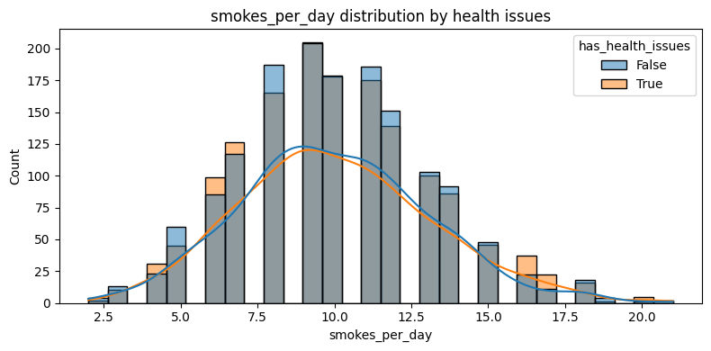
Note. The graph shows that individuals with health issues are more likely to smoke daily or in higher quantities compared to those without health issues. This visual reinforces the narrative that smoking is a significant behavioral factor impacting health.
On the other hand, while the drinking behavior distribution (Figure 10) shows no strong pattern overall, individuals with health issues tend to drink more frequently in the lower consumption ranges. This could be reflective of a coping mechanism or a dependency in certain cases.
Figure 10. Drinking Behavior by Health Issues 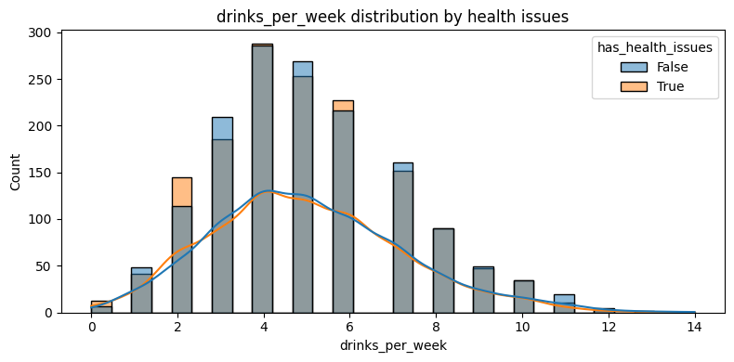
Note. The graph highlights that while drinking habits vary, individuals with health issues seem to drink more frequently in the lower consumption ranges, suggesting that alcohol consumption may serve as a coping mechanism for some.
6. Methodology/Strategies
This project utilizes predictive analytics to investigate how addiction-related behaviors and lifestyle factors influence the occurrence of health issues. The analysis is based on a structured dataset obtained from Kaggle, containing data on 3,000 individuals exhibiting patterns of alcohol and cigarette addiction. The primary objectives of this research were to analyze key lifestyle, demographic, and addiction-related variables, as well as to develop a logistic regression model to estimate the probability of health issues. This study is of significant relevance to public health, as it aims to inform preventive strategies by identifying the behaviors most predictive of adverse health outcomes.
6.1 Data Preparation Methodology
In the data cleaning process, irrelevant features such as identifiers (e.g., id, name, and city) were removed from the dataset. Missing values were checked but found to be absent, which simplified the preprocessing process. For feature transformation, categorical variables, such as gender and employment status, were encoded using either label encoding or one-hot encoding to ensure compatibility with machine learning algorithms. Additionally, log transformations were applied to features exhibiting skewed distributions, such as income and BMI, to normalize the data and mitigate the influence of outliers.
Feature selection was carried out using a correlation matrix. A heatmap was generated to visually inspect which variables were most strongly associated with the binary target variable, has_health_issues (Yes/No). The most strongly correlated explanatory variables were retained for modeling. These included smoking behavior (smokes_per_day) and drinking behavior (drinks_per_week), as well as lifestyle factors like exercise frequency, diet quality, and sleep hours. Health-related variables such as BMI, mental health status, and social support were also included.
6.2 Model Development Methodology
Logistic regression was selected as the machine learning algorithm for model development due to the binary nature of the target variable (has_health_issues: Yes/No). The model estimates the probability P(Y=1∣X)P(Y = 1 \mid X)P(Y=1∣X), where YYY represents the presence of health issues, and XXX is the vector of explanatory variables.
The model development process began with dataset loading and preprocessing. The data was loaded using the Pandas library, and categorical variables were encoded and transformed as necessary. For exploratory data analysis (EDA), summary statistics were computed, and visualizations such as boxplots and histograms were generated to examine the data distributions and detect outliers.
In the model training phase, a train-test split was performed, typically using a 70/30 or 80/20 ratio, to prevent overfitting and allow for the evaluation of model performance on unseen data. Logistic regression was then applied using the sklearn.linear_model.LogisticRegression module.
Model evaluation involved the use of accuracy, precision, recall, and confusion matrix metrics to assess the model's performance. The coefficients of the logistic regression model were examined to interpret the direction and strength of each predictor’s influence on the likelihood of health issues.
6.3 Business and Public Health Impact
By identifying key variables that contribute to health issues among individuals with addiction patterns, this project provides a data-driven foundation for public health policy-making. It offers predictive insights that can aid healthcare professionals in targeting lifestyle interventions more effectively. Furthermore, the findings support preventive health strategies for governments and NGOs by uncovering actionable variables, such as poor sleep, lack of exercise, and high substance consumption, which can be addressed to improve overall public health outcomes.
7. Business Impact and Conclusion
[=]

References
Farhud, D. D. (2015, November). Impact of Lifestyle on Health. Iranian Journal of Public Health. https://pmc.ncbi.nlm.nih.gov/articles/PMC4703222/#B1
Yadav, K. (n.d.). Cigarettes & Alcohol Addiction. Kaggle. https://www.kaggle.com/datasets/khushikyad001/cigarettes-and-alcohol-addiction/data
King, A., & Fucito, L. (2021, September 13). Cigarette smoking and heavy alcohol drinking: The challenges and opportunities for combination treatments | American Journal of Psychiatry. Psychiatry Online. https://psychiatryonline.org/doi/10.1176/appi.ajp.2021.21070692
World Health Organization. (2019, May 29). Who highlights huge scale of tobacco-related lung disease deaths. World Health Organization. https://www.who.int/news/item/29-05-2019-who-highlights-huge-scale-of-tobacco-related-lung-disease-deaths?utm_source=chatgpt.com
World Health Organization. (2023, July 31). Tobacco. World Health Organization. https://www.who.int/en/news-room/fact-sheets/detail/tobacco?utm_source=chatgpt.com
World Health Organization. (2024, June 28). Alcohol. World Health Organization. https://www.who.int/news-room/fact-sheets/detail/alcohol

Appendix
The appendix provides additional visualizations and detailed analyses that support the findings presented in the main body of the report. The figures in this section offer further insights into various demographic and lifestyle factors related to health issues, including therapy history, gender distribution, education level, employment status, smoking and drinking behaviors, as well as health-related measures such as BMI and sleep hours. These supplementary charts are intended to provide a more comprehensive understanding of the dataset and highlight correlations that may not have been fully explored in the main section of the report.
Figure A1. Therapy History by Health Issues 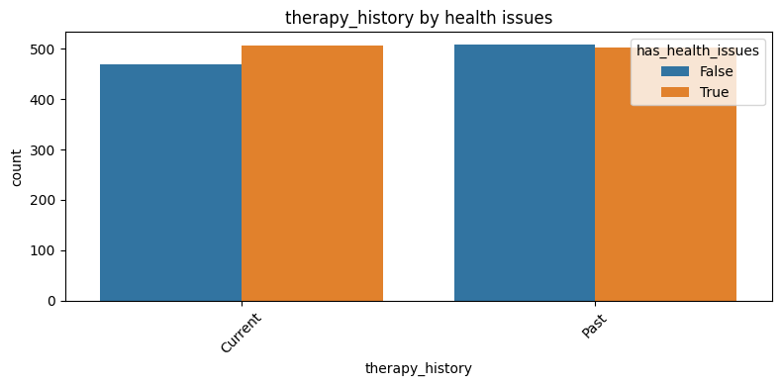
Note. This bar chart compares the therapy history of individuals with and without health issues. The data shows a relatively equal distribution between "Current" and "Past" therapy histories, with no significant trend based on health issues. This suggests that therapy history may not be strongly influenced by health status but could still provide additional context for understanding mental health.
Figure A2. Gender by Health Issues 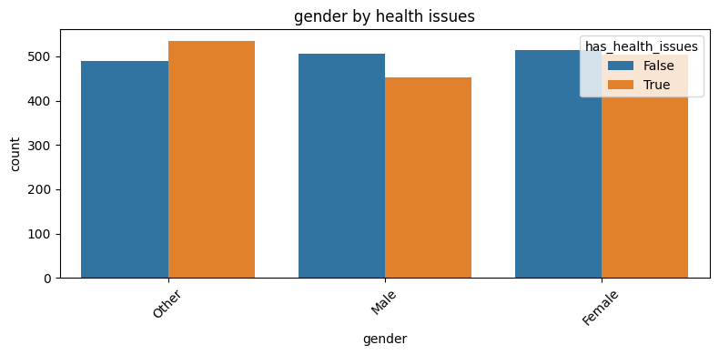
Note. This graph presents the distribution of gender among individuals with and without health issues. It shows that there are more male individuals in both health categories, though the gender distribution is relatively consistent between the two groups. This suggests that gender is not a major differentiating factor when it comes to health issues.
Figure A3. Education Level by Health Issues 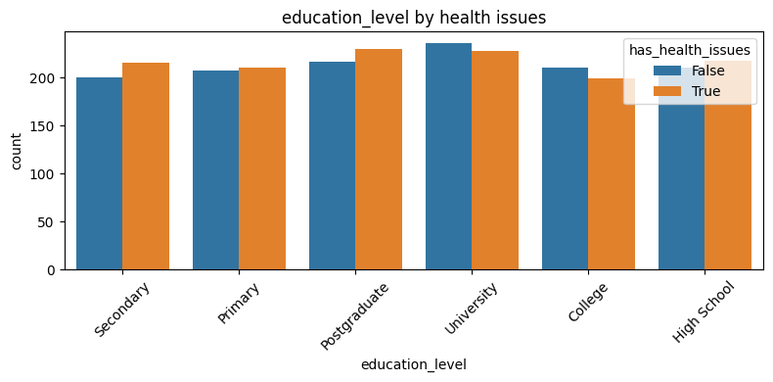
Note. This chart compares the education level of individuals with and without health issues. It reveals that a higher percentage of individuals with health issues have completed secondary education or higher. However, there is no significant difference between the two groups across the education levels. This indicates that education level does not appear to be a strong factor linked to health issues.
Figure A4. Employment Status by Health Issues 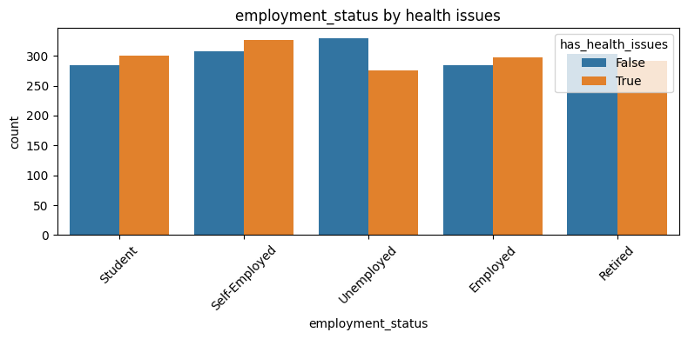
Note. This figure shows the employment status distribution of individuals with and without health issues. Individuals without health issues appear to have a higher proportion of employed and self-employed individuals, while those with health issues report more individuals in the "Unemployed" and "Student" categories. This suggests that employment status may be affected by health issues.
Figure A5. Attempt to Quit Smoking/Drinking Distribution by Health Issues 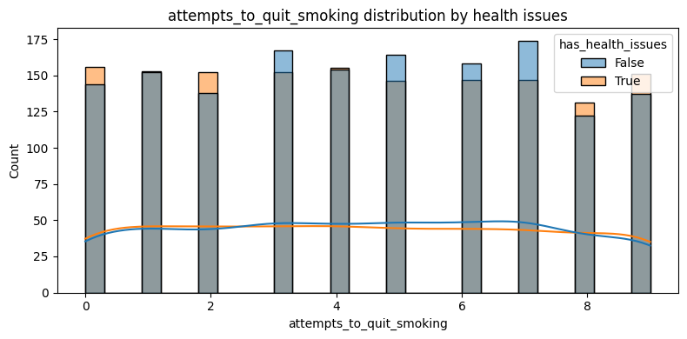
Note. This series of bar charts compares the number of attempts to quit smoking and drinking between individuals with and without health issues. The data shows more frequent attempts to quit smoking and drinking among individuals with health issues, indicating that those with health issues may be more motivated to change these behaviors. However, the frequency of attempts varies, with a greater number of individuals reporting fewer attempts.
Figure A6. BMI, Sleep Hours, and Other Distributions by Health Issues 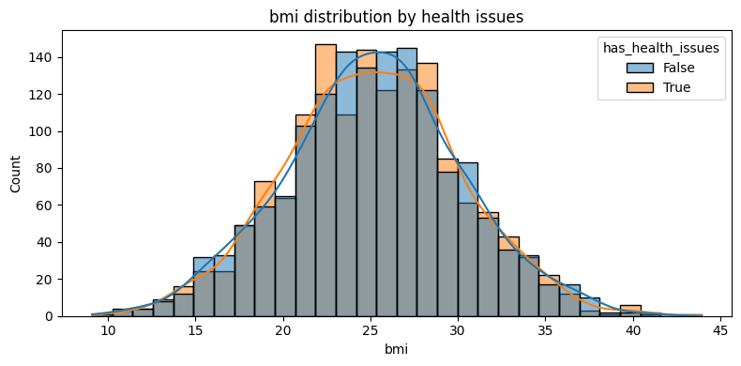
Note. This set of distributions compares Body Mass Index (BMI), sleep hours, and other health-related factors between individuals with and without health issues. The charts suggest that individuals with health issues tend to have a higher average BMI and fewer sleep hours, highlighting potential lifestyle differences between the two groups. These factors may influence or be influenced by the presence of health issues.
Figure A7. Correlation Heatmap
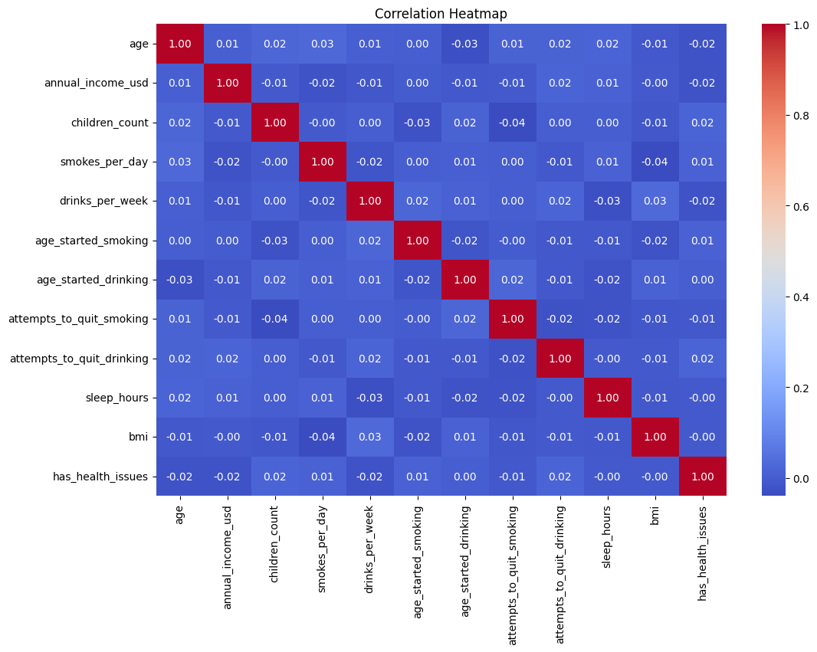
The correlation heatmap displays the relationships between various variables in the dataset. The chart reveals that "smokes_per_day" and "drinks_per_week" show moderate correlation, suggesting that individuals who smoke also tend to drink more. Additionally, the correlation between age and health issues is weak, indicating that age does not strongly influence the likelihood of reporting health issues. This heatmap provides a deeper, statistical look at variable interrelationships in the dataset.

